

**SCHOOL OF INFORMATION SCIENCE**

**COLLEGE OF COMPUTING, INFORMATICS AND MATHEMATICS**

**UNIVERSITI TEKNOLOGI MARA (UiTM), KEDAH BRANCH**

Diploma in Library Informatics

(CDIM 144)

Programming for Libraries

(IML208)

**REPORT ON INDIVIDUAL PROJECT:**

**ONE PIECE FAN CLUB REGISTRATION**

PREPARED BY:

MUHAMMAD NASHRUL HAKIMIE BIN SUPARDI

2022489454

KCDIM1443C

PREPARED FOR:

EN.MOHD FIRDAUS BIN MOHD HELMI

SUBMISSION DATE:

10th DECEMBER 2023

**PROJECT NAME:**

ONE PIECE FAN CLUB REGISTRATION

**FILE NAME:**

INDIVIDUAL ASSIGNMENT 208.py

ABSTRACT

The One Piece Fan Club Registration is a system registration that prioritise One Piece anime fans. This Fan club registration can offer various benefits for both fans and the individuals or entities they support. The benefit that will users gain is can access to exclusive content such as behind-the-scenes footage, unreleased songs, special interviews, or sneak peeks. This creates a sense of exclusivity and privilege for fans. Joining a fan club provides a platform for fans to connect with like-minded individuals who share similar interests. This sense of community can enhance the overall fan experience, allowing members to discuss their favourite topics and share their passion. For the lastly is being part of a fan club fosters a sense of belonging and loyalty. Fans feel like they are part of a special group, sharing a unique connection with the artist or brand they admire. Fans should consider their level of devotion and the perks offered before deciding to join.

**PROMPT DATA (**Data to be entered by the admin)

1. Fans username

2. Fans email

3. Fans favourite character

**AVAILABLE FUNCTION**

1. Username data

2. Email data

3. Favourite character data

4. Add favourite data

5. Delete favourite data

6. Register data

7. Read data

8. Update data

9. Delete data

GRAPHICAL USER INTERFACE (GUI) – YES

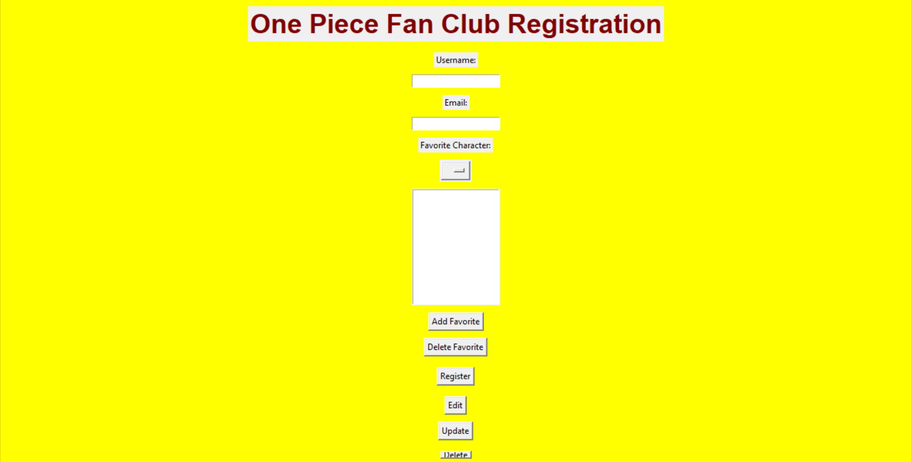

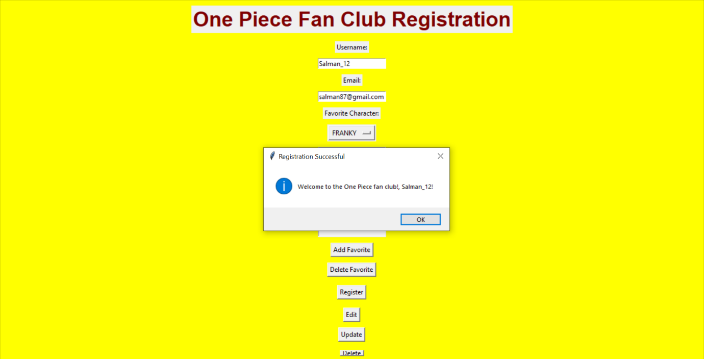

**STRENGTH**

1) Data is safe and preserved

2) Button neat and tidy

3) Honing admin talent in leading information technology

**KAIZEN**

My honestly idea is to add color on button type for decorate more nicely and make users feel satisfied to register. I want to add Fan Feedback which aims to see comments from fans when registering in this system. Lastly is I want to make it Mobile-Friendly Platformto ensure the registration platform is mobile-friendly for easy access on smartphones and tablets.